Elbow joint
Type – hinge variety of synovial joint
Compound joint – humerus, ulna and radius take part in formation of elbow

Articulating surfaces
- Lower end of humerus – capitulum and trochlea
- Upper end of ulna (olecranon process, trochlear notch) articulates with trochlea of humerus and forms humeroulnar joint
- Upper end of radius (head of radius) articulates with capitulum forming humeroradial joint
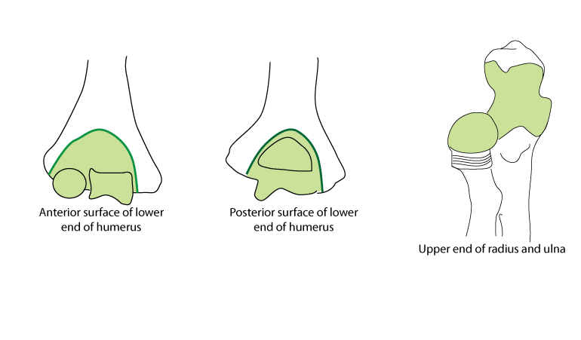

Angles related to elbow
- The trochlea normally is tilted in 4° of valgus in males and 8° of valgus in females, thus creating the carrying angle of the elbow.
- The trochlea also is externally rotated 3-8° from a line connecting the medial and lateral epicondyles, resulting in external rotation of the arm when the elbow is flexed 90°.

Ligaments

Fibrous capsule
- Superiorly – attached to humerus covering capitulum and trochlea and to margins of radial, coronoid fossa and olecranon fossa
- Inferiorly – coronoid process of ulna, margins of olecranon process and to annular ligament of radius

Collateral ligaments
- Ulnar collateral ligament
  - Triangular in shape
  - Three parts - anterior, posterior and oblique (inferior)
  - extends on all sides of olecranon process and coronoid process
  - Ulnar nerve is in contact with the medial surface of ulnar collateral ligament
- Radial collateral ligament
  - Extends from lateral epicondyle to lateral part of annular ligament of head of radius
[TIP]Watch the video
[YOUTUBE] https://youtu.be/YfrDErYBVcY

Arterial supply - Anastomoses around elbow joint
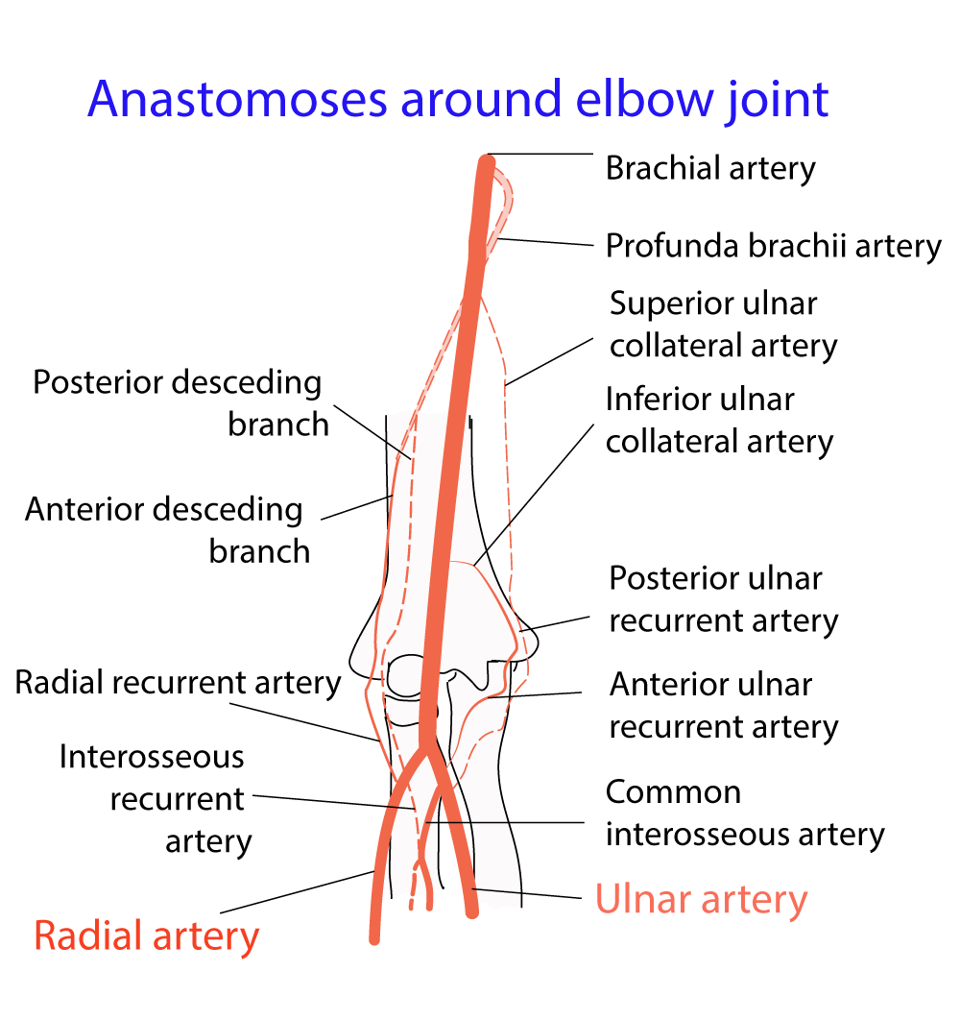
Nerve supply – articular twigs from radial nerve, musculocutaneous nerve, ulnar nerve and median nerve

Movements and muscles
Movement | Muscles
Flexion | Brachialis  Biceps brachii  Brachioradialis
Extension | Triceps brachii

Posterior elbow geometry
In flexed state – lateral epicondyle, medial epicondyle and tip of olecranon process forms an equilateral triangle.
In supracondylar fractures – equilateral triangular relationship is maintained in flexed state
In extension state – these three points are in straight line
In posterior dislocation of elbow – olecranon process lies above the line joining the medial and lateral condyles.

Pathology of elbow
Lateral tennis elbow – affects the tendinous origin of common wrist extensors
Medial Golfer’s elbow – affects the tendinous origin of flexors of fingers and pronators

